Design and Implementation of a Database Management System for Veterinary Clinic and Animal Treatment Management System
PROJECT REPORT
Project No. | 47
Student Name | Surya Siddharath Y
Roll No. | 25WU0102280
Class / Section | AI/ML (Whales)
Course | Database Management Systems (DBMS) Course Project
Faculty Name | [Faculty name: to be filled]
Academic Year | 2026-27
Final Presentation (UI Demo) | 7 October 2026

Contents
- Cover Page
- Abstract
- Introduction and Problem Statement
- Objectives and Scope
- Software and Hardware Requirements
- ER Diagram
- Relational Schema and Normalization
- Data Dictionary
- SQL Commands Used (DDL and DML) with Sample Outputs
- Queries with Outputs
- UI Design and Screenshots
- Implementation Details
- Testing
- Conclusion and Future Enhancements
- References
- Appendix: GitHub Repository Link

2. Abstract
A veterinary clinic works with owners, animals, doctors, appointments, treatments, vaccinations, medicines, laboratory tests and payments. When these records are kept on paper or in separate spreadsheets, the clinic ends up with duplicate animals, doctors booked twice for the same time, missed vaccination dates and bills that do not match the treatment given.
This project designs and implements a relational database, called vet_clinic, in MySQL, together with a web-based user interface written in Python and Streamlit. The database has 17 tables normalized to Third Normal Form (3NF), 7 views that act as reports, 5 triggers, 1 stored procedure and 5 indexes. Business rules such as "a doctor cannot have two overlapping appointments" and "payments cannot exceed the bill" are enforced inside the database itself, so no application can bypass them.
The user interface lets staff insert, view, update and delete records, book appointments, save consultations, record vaccinations, generate bills, take payments and open reports. Every action was tested against the live database, and the results are reported in Section 13.

3. Introduction and Problem Statement

3.1 Introduction
A veterinary clinic is a small hospital for animals. Every visit produces several linked records: who owns the animal, which doctor saw it, what was diagnosed, which medicines and tests were ordered, which vaccines were given, and how much the owner has to pay. A Database Management System (DBMS) stores these records in related tables, prevents invalid data through constraints, and answers questions quickly through SQL queries.
This project applies the concepts of the DBMS course (entity-relationship modelling, relational schema design, normalization, SQL, constraints, triggers, views and transactions) to build a complete working system for a veterinary clinic.

3.2 Problems with a Manual System
- The same animal is registered twice for one owner, or owner details are repeated in every visit record.
- A doctor is given two appointments at the same time because nobody checks the schedule.
- Vaccination due dates are forgotten, so animals miss their booster doses.
- A bill is added up by hand from treatments, medicines and tests, and mistakes are common.
- Payments are recorded without checking the balance, so a bill can be overpaid or left half-paid without anyone noticing.
- Finding the history of one animal means searching through many papers or files.

3.3 Problem Statement
To design and implement a Database Management System for a veterinary clinic that records pet owners and their animals, schedules appointments with veterinarians, stores consultations, diagnoses, treatments, prescriptions and laboratory tests, tracks vaccinations, and handles billing and payments, while preventing invalid or conflicting data, and to provide a user interface that performs insertion, deletion and viewing of records on the live database.

3.4 Proposed System
The proposed system stores all clinic data in one normalized MySQL database. Rules that must always hold are written as constraints and triggers in the database. A Streamlit application sends SQL to the database and shows the results, so the clinic staff never need to write SQL themselves.

4. Objectives and Scope

4.1 Objectives
- Store owners, animals, veterinarians, medicines, vaccines and tests once, without duplication.
- Prevent double booking of a veterinarian and duplicate animal names for the same owner.
- Keep a full treatment history for every animal.
- Track vaccinations and list the animals whose vaccination is due or overdue.
- Generate each bill automatically from the consultation fee, treatments, medicines and tests.
- Record payments safely and keep the bill status (Unpaid, Partial, Paid) correct.
- Provide seven reports through SQL views and a CSV download in the application.
- Provide a user interface that supports insertion, deletion and viewing of records.

4.2 Scope
Included: owner and animal registration, appointment booking, consultation (symptoms, diagnosis, treatment), prescriptions, laboratory tests, vaccination records, billing and payment, reports, and a dashboard.
Not included: user login and roles, online booking by owners, medicine stock control, and SMS or email reminders. These are listed as future enhancements in Section 14.

4.3 Business Rules
No. | Business rule
R1 | An owner cannot register two animals with the same name.
R2 | A veterinarian cannot have two overlapping appointments.
R3 | A vaccination cannot be dated in the future, and the next due date must come after the date given.
R4 | Medicine dosage, duration and quantity must be greater than zero.
R5 | The total of all payments for a bill cannot exceed the bill amount.

5. Software and Hardware Requirements

5.1 Software Requirements
Component | Details
Operating system | macOS
Database | MySQL 9.7.1 Community Server (any MySQL 8.0.16 or later works, because CHECK constraints are enforced from that version)
Programming language | Python 3
User interface framework | Streamlit 1.65.0
Database connector | mysql-connector-python 26.7.0
Data handling | pandas 3.0.6
Database tools | MySQL command-line client, MySQL Workbench
Browser | Any modern web browser (the app opens at localhost:8501)
Code editor | Any text editor or IDE

5.2 Hardware Requirements
Component | Used for this project | Minimum recommended
Computer | MacBook Air laptop | Any laptop or desktop
Processor | Apple laptop processor | Dual-core, 2 GHz or better
Memory (RAM) | Laptop standard memory | 4 GB
Storage | Free laptop storage | 2 GB free space
Display | Laptop screen | 1280 x 720 or higher
Network | Not needed (everything runs locally) | None

6. ER Diagram
The ER diagram shows the 17 entities of the veterinary clinic and the 17 relationships between them. Each arrow points from the parent table to the child table that holds its foreign key.
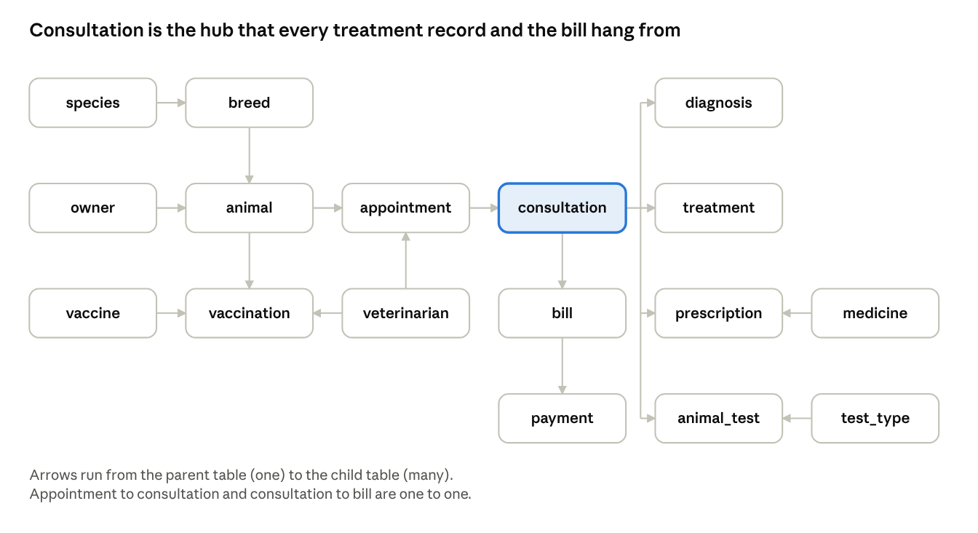
ER diagram of the 17 tables of the vet_clinic database
Figure 1: ER diagram of the vet_clinic database
The consultation table is the centre of the design: diagnoses, treatments, prescriptions, laboratory tests and the bill all belong to one consultation, and one consultation belongs to exactly one appointment. The columns of every entity are listed in Section 8.

6.1 Relationships and Cardinality
No. | Parent (one) | Child (many) | Cardinality | Foreign key
1 | owner | animal | 1 : N | animal.owner_id
2 | species | breed | 1 : N | breed.species_id
3 | breed | animal | 1 : N | animal.breed_id
4 | animal | appointment | 1 : N | appointment.animal_id
5 | veterinarian | appointment | 1 : N | appointment.vet_id
6 | appointment | consultation | 1 : 1 | consultation.appointment_id (UNIQUE)
7 | consultation | diagnosis | 1 : N | diagnosis.consultation_id
8 | consultation | treatment | 1 : N | treatment.consultation_id
9 | consultation | prescription | 1 : N | prescription.consultation_id
10 | medicine | prescription | 1 : N | prescription.medicine_id
11 | consultation | animal_test | 1 : N | animal_test.consultation_id
12 | test_type | animal_test | 1 : N | animal_test.test_type_id
13 | consultation | bill | 1 : 1 | bill.consultation_id (UNIQUE)
14 | bill | payment | 1 : N | payment.bill_id
15 | animal | vaccination | 1 : N | vaccination.animal_id
16 | vaccine | vaccination | 1 : N | vaccination.vaccine_id
17 | veterinarian | vaccination | 1 : N | vaccination.vet_id

7. Relational Schema and Normalization
The ER diagram was converted into 17 relations. Every relation has a single-column primary key (PK), and each relationship is stored as a foreign key (FK) in the child table.

7.1 Relational Schema
Relation | Primary key | Foreign keys | Other attributes
owner | owner_id | - | full_name, phone, email, address
species | species_id | - | species_name
breed | breed_id | species_id | breed_name
animal | animal_id | owner_id, breed_id | name, gender, date_of_birth, weight_kg, registered_on
veterinarian | vet_id | - | full_name, specialization, phone, consultation_fee, is_active
appointment | appointment_id | animal_id, vet_id | appt_start, appt_end, reason, status
consultation | consultation_id | appointment_id | symptoms, notes
diagnosis | diagnosis_id | consultation_id | description
treatment | treatment_id | consultation_id | description, cost
medicine | medicine_id | - | name, unit_price
prescription | prescription_id | consultation_id, medicine_id | dosage_mg, frequency, duration_days, quantity
vaccine | vaccine_id | - | name, validity_days
vaccination | vaccination_id | animal_id, vaccine_id, vet_id | given_date, next_due_date
test_type | test_type_id | - | test_name, price
animal_test | animal_test_id | consultation_id, test_type_id | test_date, result, status
bill | bill_id | consultation_id | bill_date, total_amount, status
payment | payment_id | bill_id | amount, method, paid_at

7.2 Functional Dependencies
In every relation the primary key determines all other attributes. The other important dependencies are listed below.
- owner: owner_id -> full_name, phone, email, address; phone -> owner_id; email -> owner_id
- species: species_id -> species_name; species_name -> species_id
- breed: breed_id -> species_id, breed_name; (species_id, breed_name) -> breed_id
- animal: animal_id -> owner_id, breed_id, name, gender, date_of_birth, weight_kg, registered_on; (owner_id, name) -> animal_id
- veterinarian: vet_id -> full_name, specialization, phone, consultation_fee, is_active; phone -> vet_id
- appointment: appointment_id -> animal_id, vet_id, appt_start, appt_end, reason, status
- consultation: consultation_id -> appointment_id, symptoms, notes; appointment_id -> consultation_id
- diagnosis: diagnosis_id -> consultation_id, description
- treatment: treatment_id -> consultation_id, description, cost
- medicine: medicine_id -> name, unit_price; name -> medicine_id
- prescription: prescription_id -> consultation_id, medicine_id, dosage_mg, frequency, duration_days, quantity
- vaccine: vaccine_id -> name, validity_days; name -> vaccine_id
- vaccination: vaccination_id -> animal_id, vaccine_id, vet_id, given_date, next_due_date
- test_type: test_type_id -> test_name, price; test_name -> test_type_id
- animal_test: animal_test_id -> consultation_id, test_type_id, test_date, result, status
- bill: bill_id -> consultation_id, bill_date, total_amount, status; consultation_id -> bill_id
- payment: payment_id -> bill_id, amount, method, paid_at

7.3 Normalization
The steps are easiest to follow by starting from one large "clinic visit" sheet that held every detail of a visit in a single row: owner name and phone, animal name, breed and species, veterinarian and fee, appointment time, several diagnoses, several medicines with prices, several tests with prices, the bill total and the payments. Normalization splits this sheet into the 17 relations above.
Normal form | Problem in the visit sheet | How it was removed
1NF | Repeating groups: several diagnoses, medicines, tests and payments in one row | Each repeating item became its own row in diagnosis, prescription, animal_test and payment
2NF | Partial dependencies: medicine price depends only on the medicine, test price only on the test | Prices moved to the medicine and test_type tables; every table now has a single-column key, so no partial dependency is possible
3NF | Transitive dependencies: breed -> species, animal -> owner details, appointment -> veterinarian fee | Species moved to species, owner details to owner, and the consultation fee to veterinarian
The final design is in Third Normal Form because every non-key attribute depends on the key, the whole key and nothing but the key. For tables with an extra candidate key (such as phone in owner), the determinant is also a candidate key, so the tables also satisfy BCNF.
Controlled redundancy. The column bill.total_amount can be calculated from treatments, prescriptions and tests. It is stored on purpose, so that a bill keeps the amount that was charged on the day, even if a medicine price changes later.

8. Data Dictionary
The tables below give the structure of every table in the vet_clinic database: column name, data type, key, and constraints. AI = AUTO_INCREMENT, PK = primary key, FK = foreign key, NN = NOT NULL.

8.1 owner
Column | Data type | Key | Constraints and description
owner_id | INT, AI | PK | Unique owner number
full_name | VARCHAR(100) |  | NN. Owner name
phone | VARCHAR(15) |  | NN, UNIQUE, CHECK 10 to 15 digits
email | VARCHAR(100) |  | UNIQUE, optional
address | VARCHAR(200) |  | Optional

8.2 species
Column | Data type | Key | Constraints and description
species_id | INT, AI | PK | Unique species number
species_name | VARCHAR(50) |  | NN, UNIQUE. Dog, Cat, Rabbit, Bird

8.3 breed
Column | Data type | Key | Constraints and description
breed_id | INT, AI | PK | Unique breed number
species_id | INT | FK | NN. References species
breed_name | VARCHAR(80) |  | NN. UNIQUE together with species_id

8.4 animal
Column | Data type | Key | Constraints and description
animal_id | INT, AI | PK | Unique animal number
owner_id | INT | FK | NN. References owner
breed_id | INT | FK | NN. References breed
name | VARCHAR(60) |  | NN. UNIQUE together with owner_id (rule R1)
gender | ENUM('Male','Female') |  | NN
date_of_birth | DATE |  | Optional
weight_kg | DECIMAL(6,2) |  | NN, CHECK weight_kg > 0
registered_on | DATE |  | NN, DEFAULT current date

8.5 veterinarian
Column | Data type | Key | Constraints and description
vet_id | INT, AI | PK | Unique veterinarian number
full_name | VARCHAR(100) |  | NN
specialization | VARCHAR(80) |  | Optional
phone | VARCHAR(15) |  | NN, UNIQUE
consultation_fee | DECIMAL(8,2) |  | NN, DEFAULT 300.00, CHECK >= 0
is_active | BOOLEAN |  | NN, DEFAULT TRUE

8.6 appointment
Column | Data type | Key | Constraints and description
appointment_id | INT, AI | PK | Unique appointment number
animal_id | INT | FK | NN. References animal
vet_id | INT | FK | NN. References veterinarian
appt_start | DATETIME |  | NN. Start time
appt_end | DATETIME |  | NN, CHECK appt_end > appt_start
reason | VARCHAR(200) |  | Optional
status | ENUM('Scheduled','Completed','Cancelled') |  | NN, DEFAULT 'Scheduled'. Overlap blocked by triggers (rule R2)

8.7 consultation
Column | Data type | Key | Constraints and description
consultation_id | INT, AI | PK | Unique consultation number
appointment_id | INT | FK | NN, UNIQUE. One consultation per appointment
symptoms | VARCHAR(300) |  | Optional
notes | VARCHAR(500) |  | Optional

8.8 diagnosis
Column | Data type | Key | Constraints and description
diagnosis_id | INT, AI | PK | Unique diagnosis number
consultation_id | INT | FK | NN. References consultation
description | VARCHAR(200) |  | NN

8.9 treatment
Column | Data type | Key | Constraints and description
treatment_id | INT, AI | PK | Unique treatment number
consultation_id | INT | FK | NN. References consultation
description | VARCHAR(200) |  | NN
cost | DECIMAL(8,2) |  | NN, DEFAULT 0, CHECK cost >= 0

8.10 medicine
Column | Data type | Key | Constraints and description
medicine_id | INT, AI | PK | Unique medicine number
name | VARCHAR(100) |  | NN, UNIQUE
unit_price | DECIMAL(8,2) |  | NN, CHECK unit_price >= 0

8.11 prescription
Column | Data type | Key | Constraints and description
prescription_id | INT, AI | PK | Unique prescription number
consultation_id | INT | FK | NN. References consultation
medicine_id | INT | FK | NN. References medicine
dosage_mg | DECIMAL(8,2) |  | NN, CHECK dosage_mg > 0 (rule R4)
frequency | VARCHAR(50) |  | NN. For example Twice daily
duration_days | INT |  | NN, CHECK duration_days > 0 (rule R4)
quantity | INT |  | NN, DEFAULT 1, CHECK quantity > 0 (rule R4)

8.12 vaccine
Column | Data type | Key | Constraints and description
vaccine_id | INT, AI | PK | Unique vaccine number
name | VARCHAR(100) |  | NN, UNIQUE
validity_days | INT |  | NN, CHECK validity_days > 0

8.13 vaccination
Column | Data type | Key | Constraints and description
vaccination_id | INT, AI | PK | Unique vaccination number
animal_id | INT | FK | NN. References animal
vaccine_id | INT | FK | NN. References vaccine
vet_id | INT | FK | NN. References veterinarian
given_date | DATE |  | NN. Not in the future (trigger, rule R3)
next_due_date | DATE |  | NN, CHECK next_due_date > given_date (rule R3)

8.14 test_type
Column | Data type | Key | Constraints and description
test_type_id | INT, AI | PK | Unique test number
test_name | VARCHAR(100) |  | NN, UNIQUE
price | DECIMAL(8,2) |  | NN, CHECK price >= 0

8.15 animal_test
Column | Data type | Key | Constraints and description
animal_test_id | INT, AI | PK | Unique record number
consultation_id | INT | FK | NN. References consultation
test_type_id | INT | FK | NN. References test_type
test_date | DATE |  | NN
result | VARCHAR(200) |  | Optional until the result is ready
status | ENUM('Pending','Completed') |  | NN, DEFAULT 'Pending'

8.16 bill
Column | Data type | Key | Constraints and description
bill_id | INT, AI | PK | Unique bill number
consultation_id | INT | FK | NN, UNIQUE. One bill per consultation
bill_date | DATE |  | NN, DEFAULT current date
total_amount | DECIMAL(10,2) |  | NN, CHECK total_amount >= 0
status | ENUM('Unpaid','Partial','Paid') |  | NN, DEFAULT 'Unpaid'. Updated by a trigger

8.17 payment
Column | Data type | Key | Constraints and description
payment_id | INT, AI | PK | Unique payment number
bill_id | INT | FK | NN. References bill
amount | DECIMAL(10,2) |  | NN, CHECK amount > 0. Total payments cannot exceed the bill (trigger, rule R5)
method | ENUM('Cash','Card','UPI') |  | NN
paid_at | DATETIME |  | NN, DEFAULT current time

9. SQL Commands Used (DDL and DML) with Sample Outputs
All commands are saved in one script, vet_clinic.sql, which creates the database, the tables, the indexes, the triggers, the stored procedure and the views, and then loads the sample data. The script is run from the terminal with mysql -u root -p < vet_clinic.sql.

9.1 Data Definition Language (DDL)
Create the database
DROP DATABASE IF EXISTS vet_clinic;
CREATE DATABASE vet_clinic;
USE vet_clinic;
Create tables. The three tables below show the main types of constraint; the other 14 tables follow the structure given in Section 8.
CREATE TABLE owner (
owner_id INT AUTO_INCREMENT PRIMARY KEY,
full_name VARCHAR(100) NOT NULL,
phone VARCHAR(15) NOT NULL UNIQUE,
email VARCHAR(100) UNIQUE,
address VARCHAR(200),
CONSTRAINT chk_owner_phone CHECK (phone REGEXP '^[0-9]{10,15}$')
);
CREATE TABLE animal (
animal_id INT AUTO_INCREMENT PRIMARY KEY,
owner_id INT NOT NULL,
breed_id INT NOT NULL,
name VARCHAR(60) NOT NULL,
gender ENUM('Male','Female') NOT NULL,
date_of_birth DATE,
weight_kg DECIMAL(6,2) NOT NULL,
registered_on DATE NOT NULL DEFAULT (CURRENT_DATE),
CONSTRAINT uq_animal_per_owner UNIQUE (owner_id, name),
CONSTRAINT chk_animal_weight CHECK (weight_kg > 0),
CONSTRAINT fk_animal_owner FOREIGN KEY (owner_id) REFERENCES owner(owner_id),
CONSTRAINT fk_animal_breed FOREIGN KEY (breed_id) REFERENCES breed(breed_id)
);
CREATE TABLE appointment (
appointment_id INT AUTO_INCREMENT PRIMARY KEY,
animal_id INT NOT NULL,
vet_id INT NOT NULL,
appt_start DATETIME NOT NULL,
appt_end DATETIME NOT NULL,
reason VARCHAR(200),
status ENUM('Scheduled','Completed','Cancelled') NOT NULL DEFAULT 'Scheduled',
CONSTRAINT chk_appt_time CHECK (appt_end > appt_start),
CONSTRAINT fk_appt_animal FOREIGN KEY (animal_id) REFERENCES animal(animal_id),
CONSTRAINT fk_appt_vet FOREIGN KEY (vet_id) REFERENCES veterinarian(vet_id)
);
Create indexes
CREATE INDEX idx_owner_name ON owner(full_name);
CREATE INDEX idx_animal_name ON animal(name);
CREATE INDEX idx_appt_vet_time ON appointment(vet_id, appt_start, appt_end);
CREATE INDEX idx_vacc_due ON vaccination(next_due_date);
CREATE INDEX idx_payment_bill ON payment(bill_id);
Create triggers. The first trigger enforces rule R2 (no overlapping appointments) and the second enforces rule R5 (payments cannot exceed the bill).
DELIMITER $$
CREATE TRIGGER trg_appt_no_overlap_ins BEFORE INSERT ON appointment
FOR EACH ROW
BEGIN
IF NEW.status <> 'Cancelled' AND EXISTS (
SELECT 1 FROM appointment a
WHERE a.vet_id = NEW.vet_id
AND a.status <> 'Cancelled'
AND NEW.appt_start < a.appt_end
AND NEW.appt_end > a.appt_start
) THEN
SIGNAL SQLSTATE '45000'
SET MESSAGE_TEXT = 'Veterinarian already has an overlapping appointment';
END IF;
END$$
CREATE TRIGGER trg_payment_limit BEFORE INSERT ON payment
FOR EACH ROW
BEGIN
DECLARE v_total DECIMAL(10,2);
DECLARE v_paid DECIMAL(10,2);
SELECT total_amount INTO v_total FROM bill WHERE bill_id = NEW.bill_id;
SELECT COALESCE(SUM(amount), 0) INTO v_paid FROM payment WHERE bill_id = NEW.bill_id;
IF v_paid + NEW.amount > v_total THEN
SIGNAL SQLSTATE '45000'
SET MESSAGE_TEXT = 'Payment exceeds the outstanding bill amount';
END IF;
END$$
DELIMITER ;
The script also contains a trigger that updates bill.status after each payment, a trigger that blocks future vaccination dates, and an UPDATE version of the overlap trigger.
Create the stored procedure. It builds a bill inside a transaction and rolls back on any error.
DELIMITER $$
CREATE PROCEDURE generate_bill(IN p_consultation_id INT)
BEGIN
DECLARE v_total DECIMAL(10,2);
DECLARE EXIT HANDLER FOR SQLEXCEPTION
BEGIN
ROLLBACK;
RESIGNAL;
END;
START TRANSACTION;
SELECT
v.consultation_fee
+ COALESCE((SELECT SUM(t.cost) FROM treatment t
WHERE t.consultation_id = p_consultation_id), 0)
+ COALESCE((SELECT SUM(m.unit_price * pr.quantity)
FROM prescription pr JOIN medicine m ON m.medicine_id = pr.medicine_id
WHERE pr.consultation_id = p_consultation_id), 0)
+ COALESCE((SELECT SUM(tt.price)
FROM animal_test at JOIN test_type tt ON tt.test_type_id = at.test_type_id
WHERE at.consultation_id = p_consultation_id), 0)
INTO v_total
FROM consultation c
JOIN appointment a ON a.appointment_id = c.appointment_id
JOIN veterinarian v ON v.vet_id = a.vet_id
WHERE c.consultation_id = p_consultation_id;
INSERT INTO bill (consultation_id, total_amount)
VALUES (p_consultation_id, v_total)
ON DUPLICATE KEY UPDATE total_amount = v_total;
COMMIT;
END$$
DELIMITER ;
Create a view (the outstanding bills report)
CREATE VIEW v_outstanding_bills AS
SELECT b.bill_id, o.full_name AS owner, an.name AS animal, b.total_amount,
COALESCE(SUM(p.amount), 0) AS paid,
b.total_amount - COALESCE(SUM(p.amount), 0) AS balance, b.status
FROM bill b
JOIN consultation c ON c.consultation_id = b.consultation_id
JOIN appointment a ON a.appointment_id = c.appointment_id
JOIN animal an ON an.animal_id = a.animal_id
JOIN owner o ON o.owner_id = an.owner_id
LEFT JOIN payment p ON p.bill_id = b.bill_id
GROUP BY b.bill_id, o.full_name, an.name, b.total_amount, b.status
HAVING balance > 0;
The other six views (v_animal_history, v_vaccination_due, v_doctor_schedule, v_prescriptions, v_tests and v_revenue_by_month) are created in the same way.

9.2 Data Manipulation Language (DML)
INSERT: loading records
INSERT INTO owner (full_name, phone, email, address) VALUES
('Ravi Kumar', '9876543210', 'ravi@example.com', 'Banjara Hills, Hyderabad'),
('Anita Sharma', '9876543211', 'anita@example.com', 'Madhapur, Hyderabad');
INSERT INTO animal (owner_id, breed_id, name, gender, date_of_birth, weight_kg)
VALUES (1, 1, 'Bruno', 'Male', '2021-03-12', 28.50);
INSERT INTO appointment (animal_id, vet_id, appt_start, appt_end, reason, status)
VALUES (1, 1, '2026-09-20 10:00:00', '2026-09-20 10:30:00', 'Skin allergy', 'Completed');
CALL generate_bill(1);
MySQL responds with Query OK, 1 row affected for each single-row INSERT. The sample data holds 5 owners, 7 animals, 3 veterinarians, 7 appointments, 5 consultations, 5 bills and 3 payments.
UPDATE: changing records
UPDATE animal SET weight_kg = 29.00 WHERE animal_id = 1;
UPDATE appointment SET status = 'Completed' WHERE appointment_id = 6;
DELETE: removing records
DELETE FROM owner WHERE owner_id = 6;
This works for an owner who has no animals, such as one that was just added. For an owner who still has animals, MySQL rejects the command with error 1451 (a foreign key constraint fails), so animals can never be left without an owner.
SELECT: viewing records. The output below was produced after one owner was added through the application.
SELECT owner_id, full_name, phone FROM owner ORDER BY full_name;
owner_id | full_name | phone
6 | Abhiram | 7676267618
2 | Anita Sharma | 9876543211
5 | Mohammed Imran | 9876543214
4 | Priya Nair | 9876543213
1 | Ravi Kumar | 9876543210
3 | Suresh Reddy | 9876543212

10. Queries with Outputs
The queries below use joins across several tables, views, a subquery and an aggregate with GROUP BY. All outputs were produced by MySQL on the sample data right after the script was loaded.

10.1 Query Given During Presentation-II
[Insert here the query given to you in Presentation-II, its SQL, and its output.]

10.2 Animal History (Join of Five Tables, via View)
SELECT * FROM v_animal_history WHERE animal = 'Bruno';
animal_id | animal | owner | visit_date | vet | symptoms | diagnosis
1 | Bruno | Ravi Kumar | 2026-09-20 10:00:00 | Dr. Meera Iyer | Itching, red patches | Allergic dermatitis
1 | Bruno | Ravi Kumar | 2026-10-10 12:00:00 | Dr. Sana Fathima | NULL | NULL
The second row is a future appointment that has no consultation yet, which is why the last two columns are NULL (a LEFT JOIN keeps it).

10.3 Vaccinations Due
SELECT * FROM v_vaccination_due;
animal | owner | phone | vaccine | next_due_date | days_left
Bruno | Ravi Kumar | 9876543210 | DHPP | 2026-09-01 | -36
Misty | Ravi Kumar | 9876543210 | FVRCP | 2026-10-15 | 8
Bruno | Ravi Kumar | 9876543210 | Rabies | 2026-10-20 | 13
A negative value in days_left means the vaccination is already overdue.

10.4 Doctor Schedule
SELECT * FROM v_doctor_schedule ORDER BY vet, appt_start;
vet | appt_start | appt_end | animal | owner | reason | status
Dr. Arjun Rao | 2026-09-21 11:00:00 | 2026-09-21 11:30:00 | Rocky | Anita Sharma | Limping | Completed
Dr. Arjun Rao | 2026-10-05 10:00:00 | 2026-10-05 10:30:00 | Luna | Priya Nair | Vomiting | Completed
Dr. Meera Iyer | 2026-09-20 10:00:00 | 2026-09-20 10:30:00 | Bruno | Ravi Kumar | Skin allergy | Completed
Dr. Meera Iyer | 2026-09-25 09:00:00 | 2026-09-25 09:30:00 | Misty | Ravi Kumar | Loss of appetite | Completed
Dr. Meera Iyer | 2026-10-09 10:00:00 | 2026-10-09 10:30:00 | Snowy | Mohammed Imran | Dental check | Scheduled
Dr. Sana Fathima | 2026-09-28 15:00:00 | 2026-09-28 15:45:00 | Tiger | Suresh Reddy | Annual check-up | Completed
Dr. Sana Fathima | 2026-10-10 12:00:00 | 2026-10-10 12:30:00 | Bruno | Ravi Kumar | Follow-up | Scheduled

10.5 Prescriptions
SELECT * FROM v_prescriptions;
animal | medicine | dosage_mg | frequency | duration_days | consultation_id
Misty | Amoxicillin 250mg | 250.00 | Twice daily | 5 | 3
Bruno | Cetirizine 10mg | 10.00 | Once daily | 7 | 1
Rocky | Meloxicam 1.5mg | 1.50 | Once daily | 5 | 2
Misty | Ondansetron 4mg | 4.00 | Twice daily | 3 | 3
Luna | Ondansetron 4mg | 4.00 | Twice daily | 3 | 5

10.6 Pending Laboratory Tests
SELECT * FROM v_tests WHERE status = 'Pending';
animal | test_name | test_date | status | result
Luna | Blood test (CBC) | 2026-10-05 | Pending | NULL

10.7 Outstanding Bills (Join, SUM, GROUP BY, HAVING)
SELECT * FROM v_outstanding_bills;
bill_id | owner | animal | total_amount | paid | balance | status
2 | Anita Sharma | Rocky | 1775.00 | 887.50 | 887.50 | Partial
3 | Ravi Kumar | Misty | 1672.00 | 0.00 | 1672.00 | Unpaid
5 | Priya Nair | Luna | 1272.00 | 0.00 | 1272.00 | Unpaid
Bills 1 and 4 are fully paid, so they do not appear. Bill 3 was paid later during application testing (Section 13).

10.8 Revenue by Month
SELECT * FROM v_revenue_by_month;
month | payments | revenue
2026-10 | 3 | 2493.50

10.9 Subquery: Animals Never Vaccinated
SELECT name FROM animal
WHERE animal_id NOT IN (SELECT animal_id FROM vaccination);
name
Kiwi
Snowy

10.10 Aggregate: Appointments per Veterinarian
SELECT v.full_name, COUNT(a.appointment_id) AS appointments
FROM veterinarian v LEFT JOIN appointment a ON a.vet_id = v.vet_id
GROUP BY v.vet_id, v.full_name;
full_name | appointments
Dr. Meera Iyer | 3
Dr. Arjun Rao | 2
Dr. Sana Fathima | 2

10.11 Terminal Output
The screenshot below shows these queries running in the MySQL terminal.
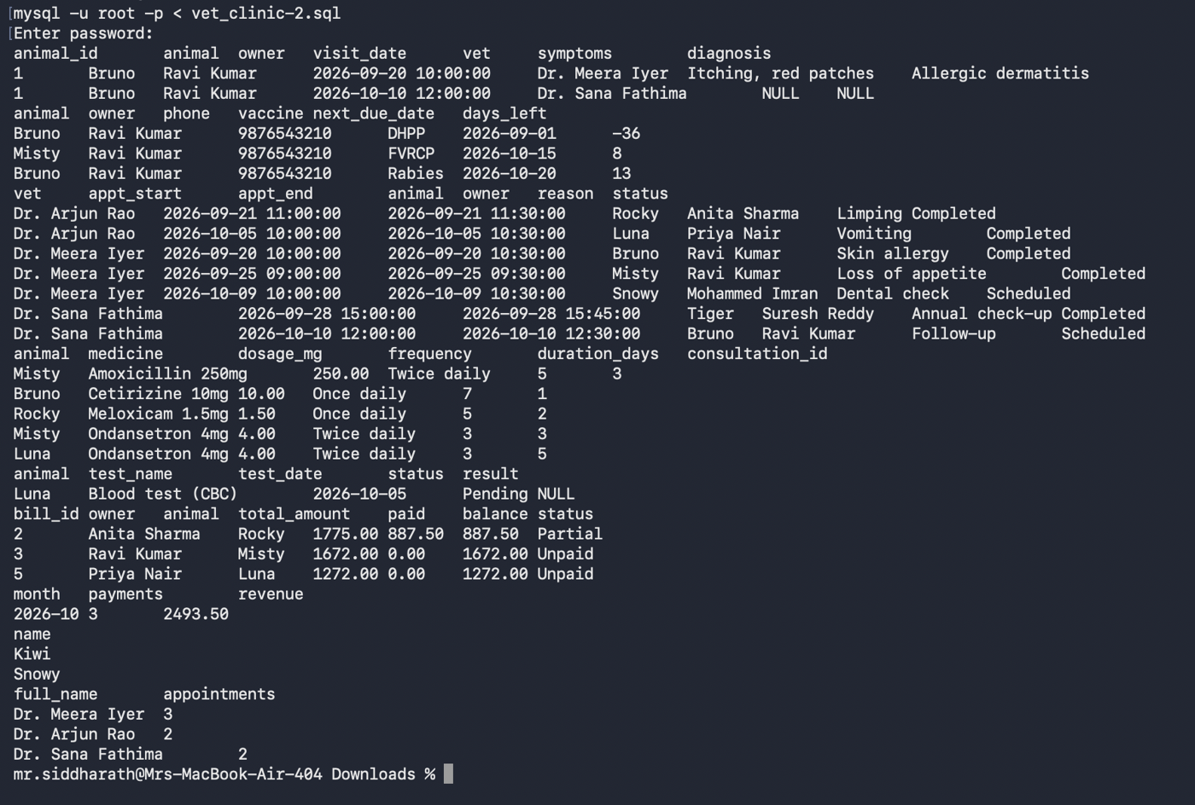
Figure 2: Output of the report queries in the terminal

11. UI Design and Screenshots

11.1 Design of the User Interface
The user interface is a web application built with Streamlit. A sidebar on the left lists the nine pages, and the page content opens on the right. Pages that manage records use tabs (View, Add, Update, Delete) so that each operation has its own screen. Forms check the input before it is sent to the database, successful actions show a green message, and rejected actions show a red message that carries the database's own explanation.
Page | What the user can do
Dashboard | See the number of owners, animals and upcoming appointments, the revenue collected, and the upcoming schedule
Owners | View and search, add, update and delete owners
Animals | View and search, register, update and delete animals
Appointments | Book an appointment, see the schedule by veterinarian, change the status
Consultation | Save symptoms, notes, diagnosis and treatment for an appointment
Prescriptions and tests | Add medicines and laboratory tests to a consultation
Vaccination | Record a vaccination and list the vaccinations that are due
Billing and payment | Generate a bill, record a payment, list the outstanding bills
Reports | Open any of the reports and download it as a CSV file

11.2 Screenshots
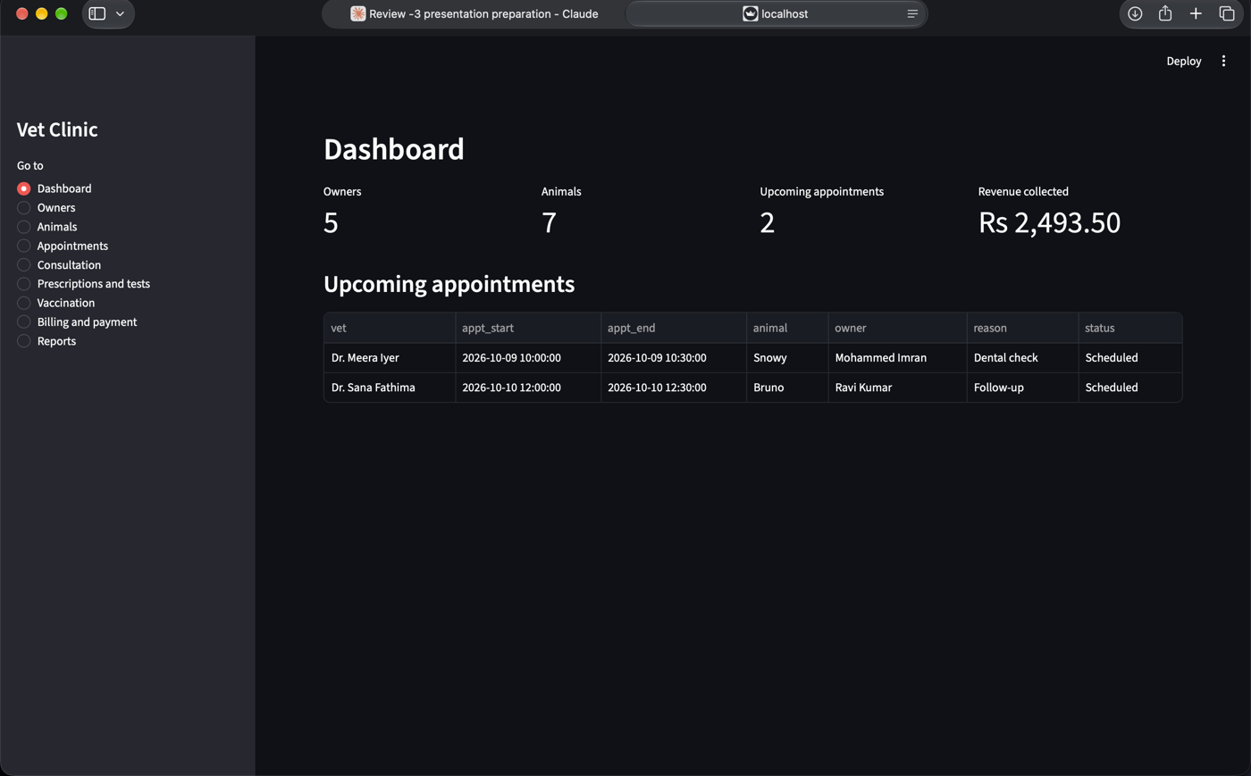
Figure 3: Dashboard. The counts are read live from the database.
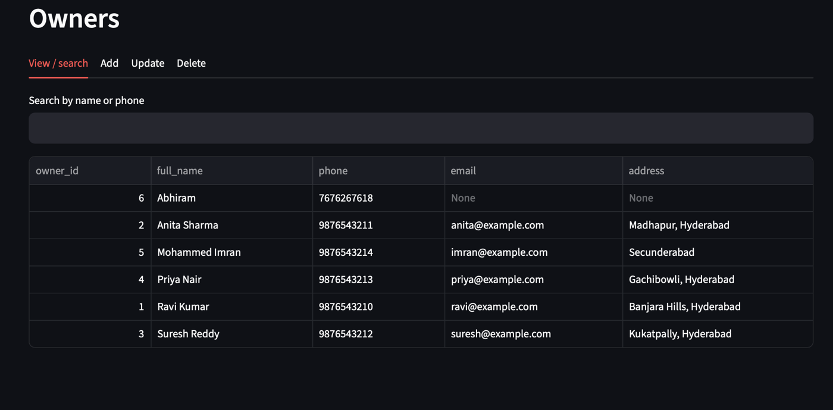
Figure 4: Owners page (view). The owner added through the form (Abhiram, owner_id 6) now appears in the list.
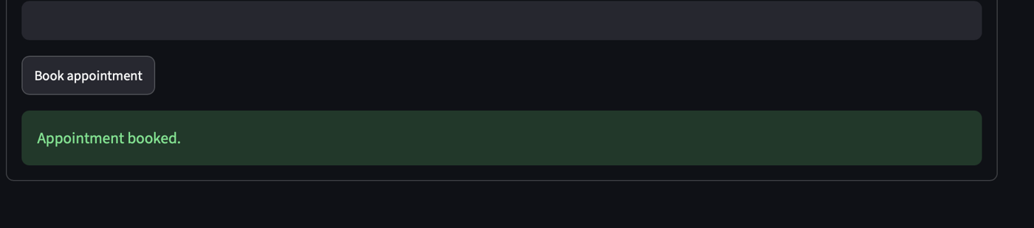
Figure 5: Appointment booking. The green message confirms that the row was saved.
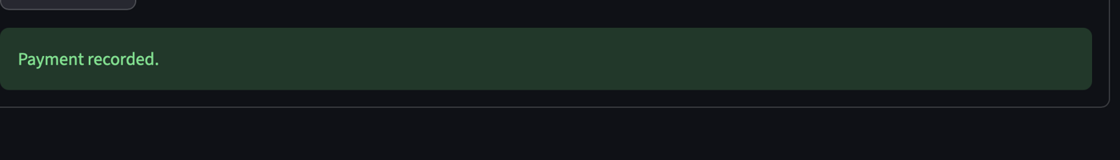
Figure 6: Payment recorded against a bill.
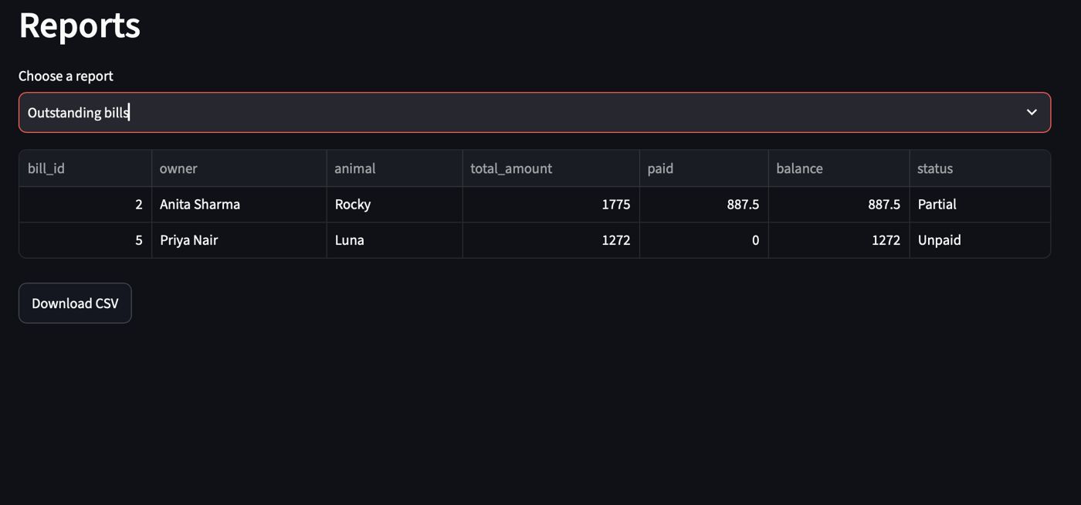
Figure 7: Outstanding bills report. Fully paid bills no longer appear.
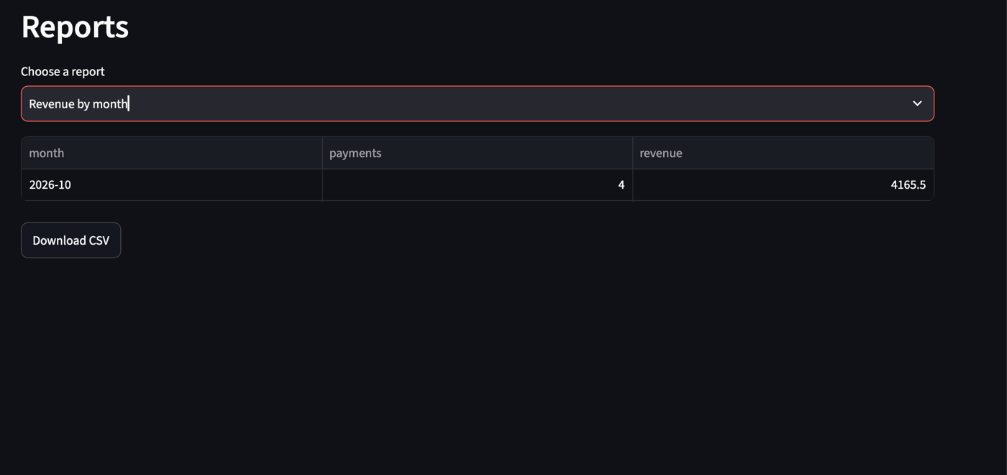
Figure 8: Revenue by month report after the payment in Figure 6.
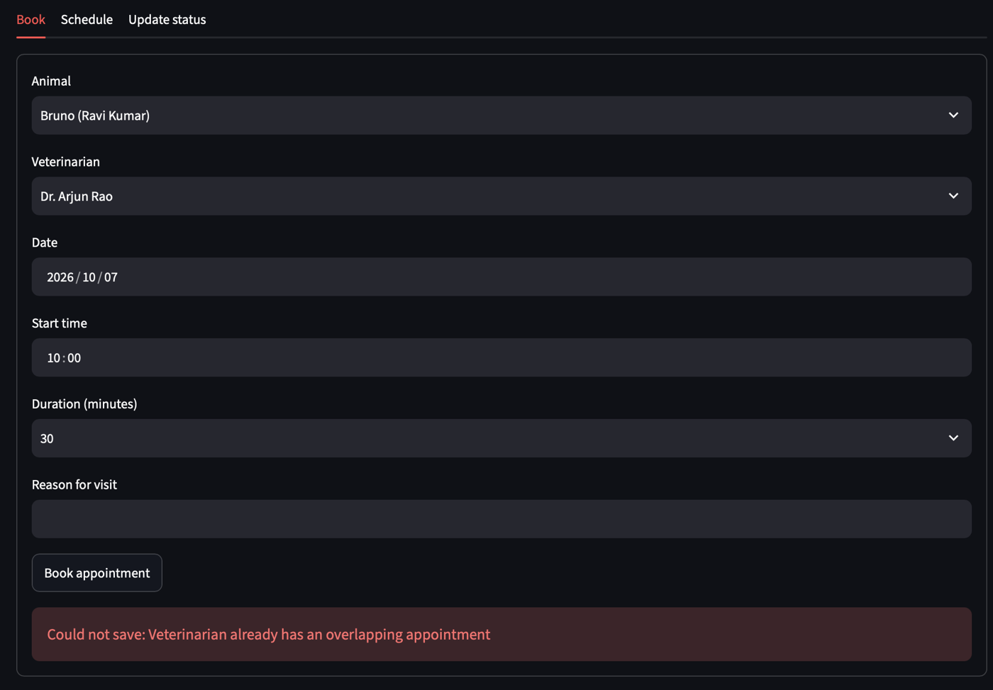
Figure 9: Business rule R2 in action. The database rejects an appointment that overlaps another appointment of the same veterinarian.

11.3 Screens for Insert, Delete and View (Before and After)
[Insert screenshot: Owners, Add tab, form filled in, before saving]
[Insert screenshot: Owners, View tab, list before the deletion]
[Insert screenshot: Owners, Delete tab, owner selected and confirmed]
[Insert screenshot: Owners, View tab, list after the deletion]
[Insert screenshot: MySQL terminal, SELECT * FROM owner before and after]

12. Implementation Details

12.1 Technology Stack
Layer | Technology | Role
User interface | Streamlit (Python) | Pages, forms, tables, buttons, messages
Application logic | Python 3 | Validation, calling the database, showing results
Database connectivity | mysql-connector-python | Sends SQL to MySQL and returns the rows
Data handling | pandas | Turns query results into tables for display and CSV download
Database | MySQL 9.7.1 | Stores the data and enforces the business rules

12.2 How the Layers Work Together
The user fills a form in the browser. Python checks the input (for example that the phone number has 10 to 15 digits), then sends an SQL statement to MySQL using placeholders (%s), which also protects against SQL injection. MySQL checks the constraints and triggers. If everything passes, the row is saved and a green message is shown. If a rule fails, MySQL raises an error, Python catches it, and the user sees the message in red. No business rule lives only in the interface: the same rules apply to anyone who connects to the database.

12.3 Database Connectivity
The connection settings are read from environment variables, with defaults for a local MySQL server. The password is never written in the code.
DB = dict(
host=os.getenv("DB_HOST", "localhost"),
user=os.getenv("DB_USER", "root"),
password=os.getenv("DB_PASSWORD", ""),
database=os.getenv("DB_NAME", "vet_clinic"),
)
def conn():
return mysql.connector.connect(**DB)
Two helper functions are used by every page. query() runs a SELECT and returns a table; execute() runs an INSERT, UPDATE or DELETE, commits it, and shows the result.
def query(sql, params=None):
try:
c = conn()
try:
cur = c.cursor(dictionary=True)
cur.execute(sql, params or ())
return pd.DataFrame(cur.fetchall())
finally:
c.close()
except mysql.connector.Error as e:
st.error(f"Database error: {e.msg}")
return pd.DataFrame()
def execute(sql, params=None, ok="Saved successfully."):
try:
c = conn()
try:
cur = c.cursor()
cur.execute(sql, params or ())
c.commit()
st.success(ok)
return True
except mysql.connector.Error:
c.rollback()
raise
finally:
c.close()
except mysql.connector.Error as e:
st.error(f"Could not save: {e.msg}")
return False

12.4 Key Code Snippets
Input validation
def valid_phone(p):
return bool(re.fullmatch(r"[0-9]{10,15}", p or ""))
def valid_email(e):
return (not e) or bool(re.fullmatch(r"[^@\s]+@[^@\s]+\.[^@\s]+", e))
Insert: adding an owner
with st.form("add_owner", clear_on_submit=True):
name = st.text_input("Full name")
phone = st.text_input("Phone (10-15 digits)")
email = st.text_input("Email (optional)")
addr = st.text_input("Address")
if st.form_submit_button("Add owner"):
if not name.strip():
st.error("Name is required.")
elif not valid_phone(phone):
st.error("Phone must be 10 to 15 digits.")
elif not valid_email(email):
st.error("Email format is invalid.")
else:
execute("INSERT INTO owner (full_name, phone, email, address) VALUES (%s,%s,%s,%s)",
(name.strip(), phone, email or None, addr or None), "Owner added.")
View: searching owners
term = st.text_input("Search by name or phone", key="own_search")
like = f"%{term}%"
show(query("""SELECT owner_id, full_name, phone, email, address FROM owner
WHERE full_name LIKE %s OR phone LIKE %s ORDER BY full_name""", (like, like)))
Delete: removing an owner, with confirmation
if st.checkbox("I confirm the deletion", key="del_own_ok") and st.button("Delete owner"):
execute("DELETE FROM owner WHERE owner_id=%s", (oid,), "Owner deleted.")
Transaction: saving a consultation. The consultation, diagnosis, treatment and appointment status are saved together. If any step fails, nothing is saved.
c = conn()
try:
cur = c.cursor()
cur.execute("INSERT INTO consultation (appointment_id, symptoms, notes) VALUES (%s,%s,%s)",
(aid, symptoms or None, notes or None))
cid = cur.lastrowid
cur.execute("INSERT INTO diagnosis (consultation_id, description) VALUES (%s,%s)",
(cid, diagnosis.strip()))
cur.execute("INSERT INTO treatment (consultation_id, description, cost) VALUES (%s,%s,%s)",
(cid, treatment.strip(), cost))
cur.execute("UPDATE appointment SET status='Completed' WHERE appointment_id=%s", (aid,))
c.commit()
except mysql.connector.Error:
c.rollback()
raise
finally:
c.close()
Calling the stored procedure to generate a bill
c = conn()
c.cursor().callproc("generate_bill", (cid,))
c.commit()
c.close()

13. Testing

13.1 Test Cases and Results
Every test below was run on the live application connected to the vet_clinic database.
No. | Test | Input | Expected result | Actual result | Status
T1 | Insert an owner | Name Abhiram, phone 7676267618, email and address left blank | Owner saved and visible in the owners list | Owner saved as owner_id 6 and shown in the list (Figure 4) | Passed
T2 | Book an appointment | Bruno with Dr. Arjun Rao, 7 Oct 2026, 10:00, 30 minutes | Appointment saved | Green message "Appointment booked." (Figure 5) | Passed
T3 | Overlapping appointment (R2) | Same veterinarian, date and time as T2 | Rejected with an overlap message | Red message "Veterinarian already has an overlapping appointment" (Figure 9) | Passed
T4 | Record a payment | Pay bill 3 (Misty) in full | Payment saved and bill status updated | Green message "Payment recorded." (Figure 6) | Passed
T5 | Outstanding bills report | Open the report after T4 | Bill 3 no longer listed | Only bills 2 and 5 listed (Figure 7) | Passed
T6 | Revenue report | Open the report after T4 | Revenue grows by the amount paid | Revenue rose from 2493.50 to 4165.50 and payments from 3 to 4; the difference of 1672.00 equals bill 3 (Figure 8) | Passed
T7 | Dashboard counts | Open the dashboard | Counts match the database | 5 owners, 7 animals, 2 upcoming appointments, Rs 2,493.50 revenue (Figure 3) | Passed
T8 | Database script | Run vet_clinic.sql from the terminal | Script runs without error and every query returns rows | All reports returned the expected rows (Section 10) | Passed
[Add the results of the remaining rule tests here: duplicate animal name (R1), zero dosage (R4), payment above the balance (R5) and future vaccination date (R3).]

13.2 Problems Found and How They Were Fixed
Problem | Cause | Fix
MySQL error 1442 while loading the sample payments | A statement read the bill table while the payment trigger was updating it | The payment amounts are read into variables first, then inserted with explicit values
A CHECK constraint cannot compare a column with the current date | MySQL does not allow non-deterministic functions in CHECK | The rule "no future vaccination date" is enforced by a BEFORE INSERT trigger
Two appointments for one veterinarian can overlap in time | A simple UNIQUE key cannot compare time ranges | A trigger checks that the new start is before the old end and the new end is after the old start
Table display argument rejected by the newer Streamlit version | The older use_container_width argument was replaced | The code uses width="stretch"

14. Conclusion and Future Enhancements

14.1 Conclusion
The project delivers a normalized MySQL database and a working web application for a veterinary clinic. The database has 17 tables in Third Normal Form, 7 views, 5 triggers, 1 stored procedure and 5 indexes. It prevents double-booked veterinarians, duplicate animals for one owner, invalid vaccination dates, invalid dosages and overpayments, and it generates bills inside a transaction. The application inserts, views, updates and deletes records on the live database, and every change shows up in MySQL immediately.
The work also gave practical experience of the whole DBMS life cycle: requirement analysis, ER modelling, mapping to relations, normalization, writing SQL, enforcing integrity with constraints and triggers, connecting an application to the database, and testing.

14.2 Future Enhancements
- Login with separate roles for receptionist, veterinarian and administrator.
- SMS or email reminders for appointments and vaccinations that are due.
- Medicine stock control with reorder alerts.
- An owner portal for online booking and for viewing an animal's history.
- Charts on the dashboard for revenue and visits.
- An audit table that records who changed which record and when.
- Deployment on a cloud server with automatic database backups.

15. References
- MySQL Reference Manual, Oracle Corporation (dev.mysql.com/doc).
- MySQL Connector/Python Developer Guide, Oracle Corporation (dev.mysql.com/doc).
- Streamlit Documentation (docs.streamlit.io).
- pandas Documentation (pandas.pydata.org).
- R. Elmasri and S. B. Navathe, Fundamentals of Database Systems, Pearson.
- A. Silberschatz, H. F. Korth and S. Sudarshan, Database System Concepts, McGraw-Hill.
- DBMS Course Project: Final Presentation Instructions, AIML Whales and AIML Panthers, October 2026.

16. Appendix: GitHub Repository Link
Repository: [Insert the link, in the form https://github.com/your-username/DBMS-Course-Project]
Folder | Contents
Presentation-I | Problem description slides
Presentation-II | Slides, ER diagram image, the .sql file with all commands, and the solution to the Presentation-II query
Presentation-III | User interface demo slides, source code (app.py), and screenshots of every screen
Project-Report | This report as a PDF

Design and Implementation of a Database Management System for Veterinary Clinic and Animal Treatment Management System
DBMS Project-Based Learning (PBL) - Project 47 | Consolidated Report: Review 1, Review 2 and Review 3
Student Name | Surya Siddharath Y
Roll No. | 25WU0102280
Class / Section | AI/ML (Whales)
Date | 7 October 2026

1. Abstract
Veterinary clinics handle owners, animals, appointments, treatments, vaccinations, medicines, tests and payments. Managing these on paper or in loose spreadsheets leads to duplicate records, double-booked doctors, missed vaccination dates and billing mistakes. This project designs and implements a relational database in MySQL, together with a Python (Streamlit) application, that manages the complete workflow of a veterinary clinic. The database is normalized to Third Normal Form (3NF), enforces business rules through constraints and triggers, and exposes seven reports through SQL views. The report covers all three reviews: problem definition and design (Review 1), database implementation (Review 2) and the working application with testing (Review 3).

2. Review 1 - Problem Definition and Design

2.1 Problem Statement
To design and implement a Database Management System for a veterinary clinic that records pet owners and their animals, schedules appointments with veterinarians, stores consultations, diagnoses, treatments, prescriptions and tests, tracks vaccinations, and handles billing and payments, while preventing invalid or conflicting data.

2.2 Objectives
- Store owner, animal, veterinarian, medicine, vaccine and test information without duplication.
- Prevent double-booking of a veterinarian and duplicate animal registrations for the same owner.
- Keep a complete treatment history for every animal.
- Track vaccination dates and list animals whose vaccinations are due.
- Generate bills automatically from consultation, treatment, medicine and test charges, and record payments safely.
- Provide reports for animal history, vaccination due, doctor schedule, prescriptions, tests, outstanding bills and revenue.

2.3 Scope and Modules
- Owner and animal registration
- Appointment booking
- Consultation (symptoms, diagnosis, treatment)
- Vaccination records
- Prescription
- Tests
- Billing and payment
- Reports

2.4 Entities and Relationships
The main entities are Owner, Animal, Species, Breed, Veterinarian, Appointment, Consultation, Diagnosis, Treatment, Medicine, Prescription, Vaccine, Vaccination, Test Type, Animal Test, Bill and Payment.
- One owner has many animals (1:N).
- One species has many breeds, and each animal belongs to one breed (1:N).
- One animal has many appointments, and one veterinarian has many appointments (1:N each).
- One appointment has at most one consultation (1:1).
- One consultation has many diagnoses, treatments, prescriptions and tests (1:N each).
- Medicines and test types are catalogue tables linked to prescriptions and tests (1:N).
- One animal has many vaccinations, each linked to a vaccine and a veterinarian.
- One consultation has one bill, and one bill has many payments (1:N).

2.5 Business Rules
No. | Rule
R1 | An owner cannot register two animals with the same name.
R2 | A veterinarian cannot have two overlapping appointments.
R3 | A vaccination cannot be recorded with a future date, and the next due date must be after the given date.
R4 | Medicine dosage, duration and quantity must be positive.
R5 | Total payments for a bill cannot exceed the bill amount.

2.6 Technology Choice
MySQL is used as the database because it is a widely used relational system with support for constraints, triggers, views and stored procedures. Python with Streamlit is used for the front end because it allows forms, tables and reports to be built quickly while keeping all data logic in the database.

3. Review 2 - Database Design and Implementation

3.1 Schema Summary
The database vet_clinic contains 17 tables, 7 views, 5 triggers, 1 stored procedure and 5 indexes.
Table | Primary key | Foreign keys | Key constraints
owner | owner_id | - | phone UNIQUE and format CHECK, email UNIQUE
species | species_id | - | species_name UNIQUE
breed | breed_id | species_id | UNIQUE (species_id, breed_name)
animal | animal_id | owner_id, breed_id | UNIQUE (owner_id, name), weight CHECK > 0
veterinarian | vet_id | - | phone UNIQUE, fee CHECK >= 0
appointment | appointment_id | animal_id, vet_id | CHECK end > start, status ENUM, overlap trigger
consultation | consultation_id | appointment_id | appointment_id UNIQUE
diagnosis | diagnosis_id | consultation_id | description NOT NULL
treatment | treatment_id | consultation_id | cost CHECK >= 0
medicine | medicine_id | - | name UNIQUE, price CHECK >= 0
prescription | prescription_id | consultation_id, medicine_id | dosage, duration, quantity CHECK > 0
vaccine | vaccine_id | - | name UNIQUE, validity CHECK > 0
vaccination | vaccination_id | animal_id, vaccine_id, vet_id | CHECK next_due > given, date trigger
test_type | test_type_id | - | name UNIQUE, price CHECK >= 0
animal_test | animal_test_id | consultation_id, test_type_id | status ENUM
bill | bill_id | consultation_id | consultation_id UNIQUE, total CHECK >= 0
payment | payment_id | bill_id | amount CHECK > 0, limit trigger

3.2 Functional Dependencies
In every table the primary key determines all other attributes. The important dependencies are:
- owner: owner_id -> full_name, phone, email, address; phone -> owner_id; email -> owner_id
- species: species_id -> species_name
- breed: breed_id -> species_id, breed_name
- animal: animal_id -> owner_id, breed_id, name, gender, date_of_birth, weight_kg, registered_on; (owner_id, name) -> animal_id
- veterinarian: vet_id -> full_name, specialization, phone, consultation_fee, is_active
- appointment: appointment_id -> animal_id, vet_id, appt_start, appt_end, reason, status
- consultation: consultation_id -> appointment_id, symptoms, notes; appointment_id -> consultation_id
- diagnosis: diagnosis_id -> consultation_id, description
- treatment: treatment_id -> consultation_id, description, cost
- medicine: medicine_id -> name, unit_price; name -> medicine_id
- prescription: prescription_id -> consultation_id, medicine_id, dosage_mg, frequency, duration_days, quantity
- vaccine: vaccine_id -> name, validity_days
- vaccination: vaccination_id -> animal_id, vaccine_id, vet_id, given_date, next_due_date
- test_type: test_type_id -> test_name, price
- animal_test: animal_test_id -> consultation_id, test_type_id, test_date, result, status
- bill: bill_id -> consultation_id, bill_date, total_amount, status; consultation_id -> bill_id
- payment: payment_id -> bill_id, amount, method, paid_at

3.3 Normalization
- 1NF: every column holds a single atomic value, and there are no repeating groups. Multiple diagnoses, treatments, prescriptions and tests per consultation are stored as rows in separate tables.
- 2NF: every table uses a single-column primary key, so no non-key attribute depends on part of a key.
- 3NF: no non-key attribute depends on another non-key attribute. Owner details are not repeated in animal, species is reached through breed, the consultation fee is stored once in veterinarian, and medicine and test prices are stored once in their catalogue tables.
- Controlled redundancy: bill.total_amount is stored even though it can be calculated. This is deliberate, so a bill keeps the amount charged at the time even if prices change later.

3.4 Constraints and Business Rule Enforcement
Rule | How it is enforced
R1 Unique animal per owner | UNIQUE (owner_id, name) on animal
R2 No overlapping appointments | BEFORE INSERT and BEFORE UPDATE triggers on appointment
R3 Valid vaccination dates | CHECK (next_due_date > given_date) and a BEFORE INSERT trigger rejecting future dates
R4 Positive dosage, duration, quantity | CHECK constraints on prescription
R5 Payment limit | BEFORE INSERT trigger on payment; an AFTER INSERT trigger updates the bill status to Partial or Paid
Other integrity measures: PRIMARY KEY and FOREIGN KEY on all tables, NOT NULL on mandatory columns, DEFAULT values for status and dates, ENUM types for fixed choices, and a CHECK pattern on the owner phone number.

3.5 Indexes
Indexes were created on frequently searched columns to speed up lookups and joins: owner(full_name), animal(name), appointment(vet_id, appt_start, appt_end), vaccination(next_due_date) and payment(bill_id).

3.6 Transaction - Bill Generation
The stored procedure generate_bill calculates a bill as the veterinarian's consultation fee plus all treatment costs, plus medicine price multiplied by quantity, plus test prices. It runs inside START TRANSACTION ... COMMIT with an exit handler that rolls back on any error, so a bill is never saved half-calculated. In the application, saving a consultation (consultation, diagnosis, treatment and appointment status) is also done as a single transaction.

3.7 Views (Reports)
View | Purpose
v_animal_history | Visits, symptoms and diagnoses per animal
v_vaccination_due | Vaccinations due within 30 days or overdue
v_doctor_schedule | Appointments per veterinarian
v_prescriptions | Medicines prescribed per consultation
v_tests | Tests with status and results
v_outstanding_bills | Bills with unpaid balance
v_revenue_by_month | Payments and revenue grouped by month
The project also uses a subquery (animals never vaccinated: animal_id NOT IN (SELECT animal_id FROM vaccination)), joins across up to five tables, aggregate functions (COUNT, SUM) with GROUP BY and HAVING.

3.8 Sample Data
The script loads 5 owners, 7 animals, 3 veterinarians, 7 appointments, 5 consultations, medicines, vaccines, tests, 5 bills and 3 payments, so every report returns meaningful results.

4. Review 3 - Application, Demonstration and Testing

4.1 System Architecture
The system has three layers: a Streamlit front end (forms, tables, reports in the browser), a Python layer using mysql-connector-python (the functions query() and execute() send SQL and return results), and the MySQL database, which stores all data and enforces the business rules. Because the rules live in the database, they cannot be bypassed by any front end.
Environment: MySQL 9.7.1 Community Server, Python 3, Streamlit, mysql-connector-python, pandas, macOS.

4.2 Application Modules
Page | Functions
Dashboard | Counts of owners, animals, upcoming appointments, revenue collected, upcoming schedule
Owners | Add, search, update, delete with validation of name, phone and email
Animals | Register, search, update, delete; owner and breed selected from lists
Appointments | Book with date, time and duration; view schedule by veterinarian; update status
Consultation | Save symptoms, notes, diagnosis and treatment together as one transaction
Prescriptions and tests | Add prescriptions and tests to a consultation and view them
Vaccination | Record vaccinations (next due date calculated automatically) and view those due soon
Billing and payment | Generate bills, record payments, view outstanding bills
Reports | Eight reports with CSV download

4.3 Validation and Error Handling
- Form-level validation checks required fields, a 10 to 15 digit phone number, email format and positive numeric values before any SQL is sent.
- Database-level rules are enforced by constraints and triggers. When a rule is violated, the application catches the database error and shows a clear message such as "Veterinarian already has an overlapping appointment" instead of crashing.
- Delete operations ask for confirmation, and records referenced elsewhere cannot be deleted because of foreign keys.

4.4 Testing
No. | Test | Input | Expected result | Result
T1 | Add owner | New owner with valid 10-digit phone | Owner saved and visible in search | Passed
T2 | Book appointment | Bruno with Dr. Arjun Rao, 7 Oct 2026, 10:00, 30 min | Appointment saved | Passed
T3 | Overlapping appointment (R2) | Same veterinarian, date and time as an existing booking | Rejected with an overlap error | Passed - error shown
T4 | Record payment | Pay bill 3 (Misty) in full | Payment saved, bill removed from outstanding list | Passed
T5 | Outstanding bills report | Open report after T4 | Only bills 2 and 5 listed | Passed
T6 | Revenue report | Open report after T4 | Revenue increases by the payment amount (2493.50 to 4165.50) | Passed
T7 | Direct database check | Query the owner table in MySQL after adding an owner in the app | New owner present in the database | Passed

4.5 Output Screens
Insert screenshots under each caption:
- Figure 1: Dashboard
- Figure 2: Owners - view and search
- Figure 3: Appointment booking - success message
- Figure 4: Appointment booking - overlap error (rule R2)
- Figure 5: Payment recorded
- Figure 6: Outstanding bills report
- Figure 7: Revenue by month report
- Figure 8: ER diagram generated from MySQL Workbench

4.6 Challenges and Solutions
Challenge | Solution
A bill update inside a payment trigger conflicted with a statement that was reading the same table (MySQL error 1442) | The sample payments were inserted with explicit values instead of selecting from the bill table
A CHECK constraint cannot compare against the current date | A BEFORE INSERT trigger was used for the future-date rule on vaccinations
Two appointments for one veterinarian can overlap in time | Overlap condition (new start < existing end AND new end > existing start) checked in a trigger

5. Conclusion and Future Scope
The project delivers a normalized, constraint-driven MySQL database and a working Python application for a veterinary clinic. The database prevents double bookings, duplicate animals, invalid vaccination dates, invalid dosages and overpayments, produces seven reports through views, and uses transactions for consultation saving and bill generation.
Future scope: role-based login for receptionists and veterinarians, SMS or email reminders for vaccinations and appointments, inventory tracking for medicines, and online appointment booking for owners.

6. References
- MySQL Reference Manual (dev.mysql.com)
- Streamlit Documentation (docs.streamlit.io)
- MySQL Connector/Python Developer Guide (dev.mysql.com)
- DBMS PBL Project Statements document, Project 47

